Vigne Del Bosco

Pinot Grigio Venezia DOC

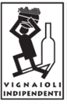

***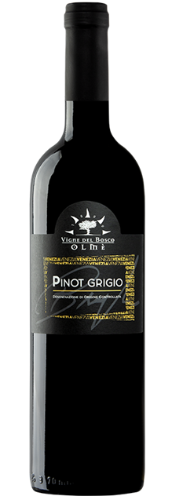

|  |  |
| --- | --- |
| ***Grape Variety*** | 100% Pinot Grigio |
| ***Vineyard Location*** | Ceggia (Venice), Veneto |
| ***Soil*** | Clay rich in salts and limestone deposits |
| ***Training System*** | Sylvoz |
| ***Vine Density*** | 2,700 vines per hectare |
| ***Yield Per Hectare*** | 8,000 / 9,000 kg. per hectare, depending on vintage |
| ***Vineyard Size*** | 10 hectares |
| ***Annual Production*** | 5,000 bottles / year |
| ***Harvest*** | Hand Harvested last 10 days of August, not looking for overripe grapes |
| ***Vinification*** | Grapes are destemmed and cooled immediately, quick soft pressing of the grapes, must clarification, low temperature controlled fermentation |
| ***Aging*** | It rests on lees for at least 6 months |
| ***Alcohol Vol*** | 12.5% |
| ***Color*** | Golden yellow with copper reflections |
| ***Aroma*** | Grapy and fruity, scent of Williams pear and ripe apple,  delicate and typical |
| ***Taste*** | Typically fresh, crisp, and dry |
| ***Food Pairing*** | Baked fish, omelets, also goes well with white meats |
| ***Serving Temperature*** | 12° C / 54° F |
| ***Type Of Cork*** | Compressed Cork Materials |
| ***Bottle Size (L)*** | 0.75 |